Exodus 40:16-38 (ESV)
¹⁶ This Moses did; according to all that the Lord commanded him, so he did. ¹⁷ In the first month in the second year, on the first day of the month, the tabernacle was erected. ¹⁸ Moses erected the tabernacle. He laid its bases, and set up its frames, and put in its poles, and raised up its pillars. ¹⁹ And he spread the tent over the tabernacle and put the covering of the tent over it, as the Lord had commanded Moses. ²⁰ He took the testimony and put it into the ark, and put the poles on the ark and set the mercy seat above on the ark. ²¹ And he brought the ark into the tabernacle and set up the veil of the screen, and screened the ark of the testimony, as the Lord had commanded Moses. ²² He put the table in the tent of meeting, on the north side of the tabernacle, outside the veil, ²³ and arranged the bread on it before the Lord, as the Lord had commanded Moses. ²⁴ He put the lampstand in the tent of meeting, opposite the table on the south side of the tabernacle, ²⁵ and set up the lamps before the Lord, as the Lord had commanded Moses. ²⁶ He put the golden altar in the tent of meeting before the veil, ²⁷ and burned fragrant incense on it, as the Lord had commanded Moses. ²⁸ He put in place the screen for the door of the tabernacle. ²⁹ And he set the altar of burnt offering at the entrance of the tabernacle of the tent of meeting, and offered on it the burnt offering and the grain offering, as the Lord had commanded Moses. ³⁰ He set the basin between the tent of meeting and the altar, and put water in it for washing, ³¹ with which Moses and Aaron and his sons washed their hands and their feet. ³² When they went into the tent of meeting, and when they approached the altar, they washed, as the Lord commanded Moses. ³³ And he erected the court around the tabernacle and the altar, and set up the screen of the gate of the court. So Moses finished the work.
³⁴ Then the cloud covered the tent of meeting, and the glory of the Lord filled the tabernacle. ³⁵ And Moses was not able to enter the tent of meeting because the cloud settled on it, and the glory of the Lord filled the tabernacle. ³⁶ Throughout all their journeys, whenever the cloud was taken up from over the tabernacle, the people of Israel would set out.
³⁷ But if the cloud was not taken up, then they did not set out till the day that it was taken up. ³⁸ For the cloud of the Lord was on the tabernacle by day, and fire was in it by night, in the sight of all the house of Israel throughout all their journeys.

Leviticus 1:1-9 (ESV)
1 The Lord called Moses and spoke to him from the tent of meeting, saying, ² “Speak to the people of Israel and say to them, When any one of you brings an offering to the Lord, you shall bring your offering of livestock from the herd or from the flock.
³ “If his offering is a burnt offering from the herd, he shall offer a male without blemish. He shall bring it to the entrance of the tent of meeting, that he may be accepted before the Lord. ⁴ He shall lay his hand on the head of the burnt offering, and it shall be accepted for him to make atonement for him. ⁵ Then he shall kill the bull before the Lord, and Aaron's sons the priests shall bring the blood and throw the blood against the sides of the altar that is at the entrance of the tent of meeting. ⁶ Then he shall flay the burnt offering and cut it into pieces, ⁷ and the sons of Aaron the priest shall put fire on the altar and arrange wood on the fire. ⁸ And Aaron's sons the priests shall arrange the pieces, the head, and the fat, on the wood that is on the fire on the altar; ⁹ but its entrails and its legs he shall wash with water. And the priest shall burn all of it on the altar, as a burnt offering, a food offering with a pleasing aroma to the Lord.

Introduction: What to do when you’re feeling lost

i) The challenge of reading Leviticus

ii) The aims of this introductory sermon

1) The goal of the book of Leviticus: God is graciously opening a way back for sinners to dwell with him

i) One key observation: The many parallels between the creation account and the tabernacle cultus

a) Sacred Space
Cosmos / Garden of Eden | Tabernacle / Holy of Holies
God creates the world in seven days (Gen 1) | Mirrored by the instructions for the construction of the tabernacle, which are structured along seven speeches of God (Exod 25 – 31)
YHWH’s depicted as ‘walking to and fro’ (hithallēk) in Eden (Gen. 3:8), | Same word used to describe the divine Presence in the later tent sanctuaries (Lev 26:12; Deut 23:15; 2 Sam. 7:6–7)
Gold, onyx, and bdellium in Eden (Gen 2:11–12) | Same materials used in tabernacle construction (Exod 25:7, 11, 17, 31)
Tree of life in the center (Gen 2:9) | Menorah symbolizes tree of life stood within the tabernacle (Exodus 25:31–40)
Garden of Eden faces East—direction from which man was expelled from the garden (Gen 3:24; 4:16) | Entrance to the tabernacle also on the east side
Cherubim guard Eden’s east entrance (Gen 3:24) | Cherubim embroidered into curtain before Holy of Holies, blocking the way westward into the Holy of Holies (Exod 26:31)

b) Sacred People

Adam / Humanity | Levites / High Priest
Adam is told to “work” [ʿabad] and “keep” [shamar] the garden (Gen 2:15) | These verbs are used together elsewhere in the Pentateuch only to describe the duties of the Levites pertaining to the tabernacle (Num. 3:7–8; 8:26; 18:5–6)
YHWH God made for Adam and for his wife tunics [kotnôt] of skins and clothed [wayyalbišēm] them (Gen 3:21) | And Moses brought Aaron’s sons and clothed wayyalbišēm] them with tunics [kuttŏnōt] (Lev 8:13)

c) Sacred Time
God’s Original Sabbath Rest | Israel’s New, Sabbatical Calendar
God rests on the seventh day (Gen 2:1–3) | Tabernacle instructions end with Sabbath command (Exodus 31:12–17)
Sabbath presented as climax/goal of creation | Leviticus climaxes with Israel basking in God’s sanctifying presence, Sabbath by Sabbath (Lev 23-25)

ii) Three implications:

a) Helps to clarify the glorious purpose of creation

b) Helps us to underscore the tragedy of the fall

c) Helps to magnify what Israel was being offered in the Levitical way

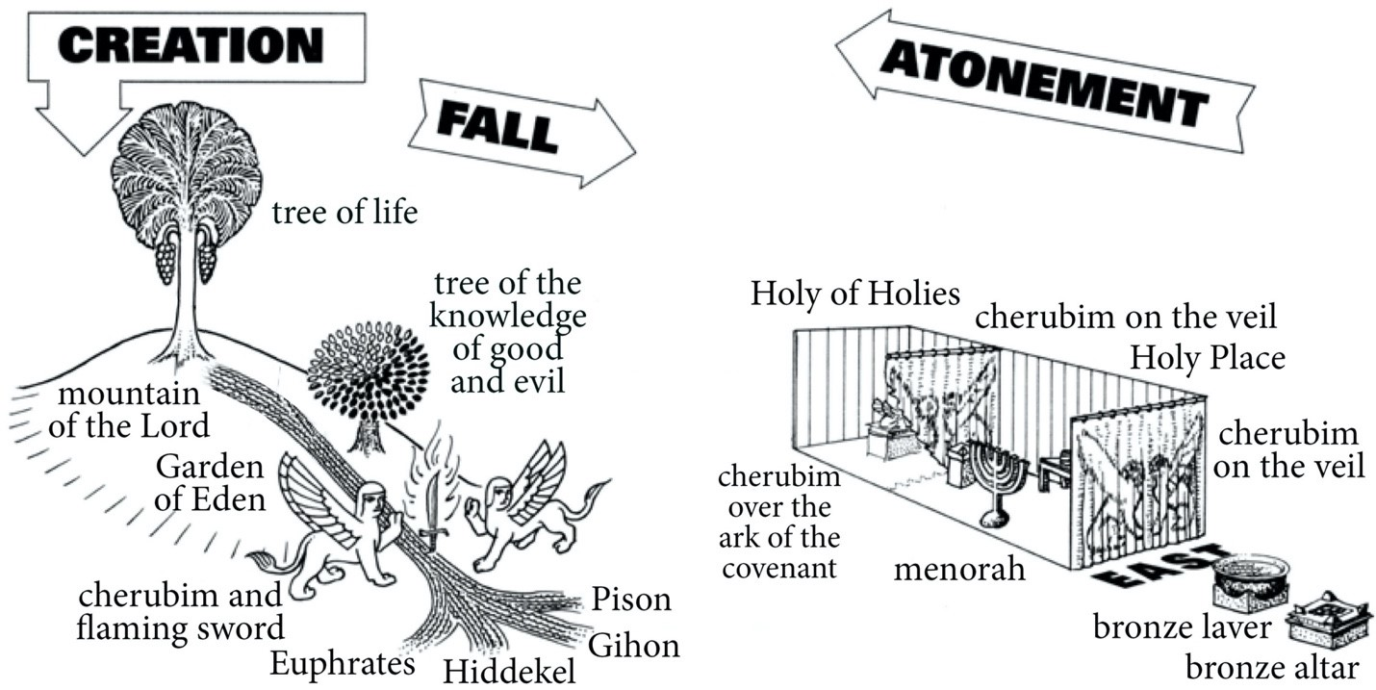

2) The shape of the Levitical way—the path back to Eden

i) The dramatic shape of Leviticus
Exodus 25:8; 29:45: God promises to dwell among his people.

This is fulfilled as the divine glory fills God’s house in Exodus in Exo 40:34.
BUT….
 | Crisis | Legislation | Resolution | Divine Presence
Exo 40-Lev 10 | No entry to God’s house (Exo 40:35) | Laws of sacrifice and consecration of priesthood (Lev 1-8) | Entry into God’s house (Lev 9) | Public theophany before the tent of mtg on 8th day (Lev 9:23) | Increasing intimacy with each theophany
Lev 11-16 | Tabernacle polluted; limits of approach to YHWH (Lev 10:1-3) | Laws of clean and unclean (Lev 11-15; cf 10:10) | Tabernacle cleansed; YHWH approached within the inner sanctum (Lev 16) | Theophany inside the inner sanctum of tent of mtg on Day of Atonement (Lev 16:2) | Increasing intimacy with each theophany
Lev 17-25 | 2nd response to Nadab and Abihu event (Lev 10:1-3) | Laws of holy/profane (Lev 17-22; cf 10:10) | Israel’s Sabbath assemblies at God’s house produce holiness (Lev 23-25) | Cultic theophany inside holy place of tent of mtg (Lev 24:1-9) | Increasing intimacy with each theophany
Covenantal application: Lev 26 | Promises and Threats: either primeval-like Presence (26:12) or primeval-like exile from Presence (26:33)

ii) The three movements of the book of Leviticus
- Approaching the House of God (Lev 1-10)
- Cleansing the House of God (Lev 11-16)
- Meeting with God at the house of God (Lev 17-27)

iii) Boiling it down further: the two halves of the book of Leviticus
- Drawing near to God via divinely ordained mediators offering divinely prescribed sacrifices (Lev 1-16)

- In order to dwell in his sanctifying presence (Lev 17-27)

Conclusion

